Deserts
What is a desert?
A desert can be described as a vast land with meager rainfall and does not support vegetation. Currently, deserts are portrayed as fascinating environments that can be visited for adventure. Deserts can be surfaced with rocks or gravel with some occasional plants.
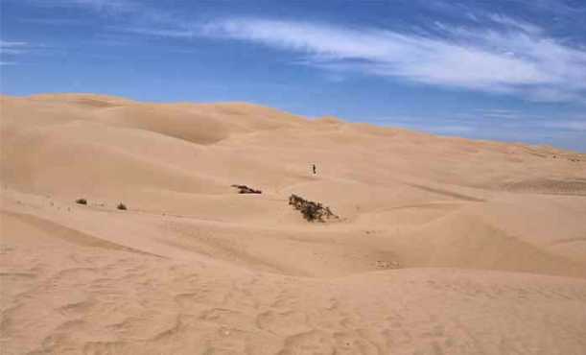
It is estimated that one-third of the Earth is a land which is surfaced by desert and contains sparse vegetation.
Vegetation in the desert
The cacti plant dominates the desert. For example in parts of Arizona near Tucson.
Most of the deserts in the world receive kess that 250millimeters of rainfall annually. On the other hand, the semiarid deserts have a mean annual precipitation of 250- 500 millimeters. Arid and extremely arid land are deserts, and semiarid grasslands are commonly refered to as as steppes.
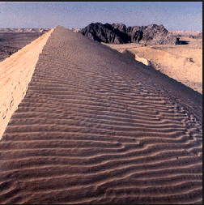
Common characteristics of a desert
- Uneven and unpredictable form of precipitation
- Poor annual precipitation
- Dryness, hot and low humidity
- High temperatures
- The desert air moves rapidly
Geomorphology of deserts
The common deserts in the North of America are;
- Mojave
- Sonoran
- Great basin
All these desserts are found in the basin and the range province which lies between the Rocky Mountains of the East and the Sierra Nevadas to the West. All these deserts have the same geological structures.
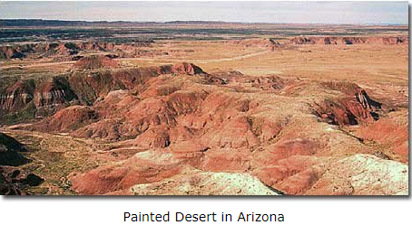
What causes deserts?
Deserts can be formed by the forces of erosion. For example desert landscapes such as the basin deserts can be as a result erosion.
Deserts can be formed by air pressure. For instance, deserts in areas with high pressure experience high pressure air forces and dry air at areas of high altitudes.
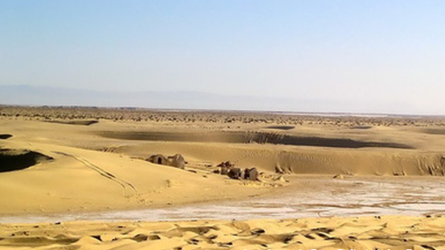
According to the New Mexico State University College of Agriculture most of the deserts in the world lie in a belt 25 degrees to either side of the equator. Most of these areas experience high atmospheric pressure.
Example of deserts which lie close to the equator and experience high atmospheric pressure include the Kalahari and the Sahara deserts.
Dusty evils of the desert
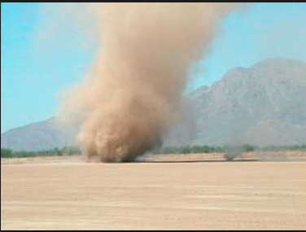
Most of the sandy deserts in the world experience dust evils. The major stimuli of dust evils in the deserts are atmospheric phenomena.
For example, the occurrence of dust devils in India can be traced way back in the Stone Age. These dusty evils are common in the in the arid regions. For example, Hyderabad-Karnatak region.
Currently, dusty evils are accepted nowadays as an atmospheric phenomenon, in rural Indian farming areas old superstitions relating to dust devils still persist. For example the farmers in the religion fear them thatthey might be the devil himself. Others believe that they come to clear what they have and immediately hold their children and their belongings and lie flat on the ground.
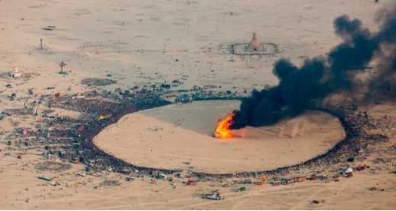
Aerial view of dust devils at the 2014 Burning Man festival in the USA. This counterculture event is held on a playa which frequently sees dust devils (a web search will find many excellent videos and photos)
The following is a list of deserts examples in the world and their features
SAHARA DESERT
Of the many deserts of the world, the Sahara Desert is the biggest desert that falls into a sub-tropical atmosphere. The Sahara covers the greater part of northeastern Africa which is about 10% of the landmass. It is about as extensive as the United States as far as land territory. It can take upwards of seven days to cross this desert via vehicle and over 40 days strolling! In spite of the fact that the Sahara is sweeping, it is actually is the third biggest desert after Antarctica and the Arctic. The Sahara reaches out from the Atlantic Ocean in the west to the Mediterranean in the north to the Red Sea in the east. 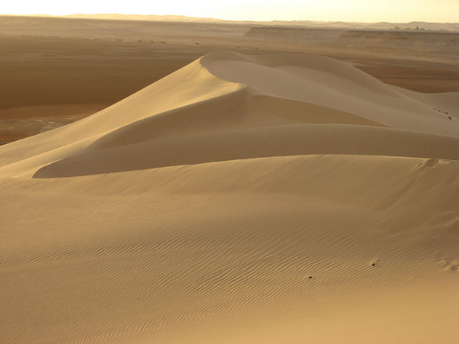
ARABIAN DESERT
The Arabian Desert is named after its area as it makes up almost the majority of the Arabian Peninsula, which incorporates the nations of Qatar, Yemen, Oman, United Arab Emirates, Kuwait, and Saudi Arabia. In the focal point of the Arabian Desert, you will locate Earth's biggest territory of whole sand called Rub'al-Khali. Whatever is left of the desert is comprised of rock fields and rough slopes. It likewise incorporates normal events of the famous and deadly "sand trap."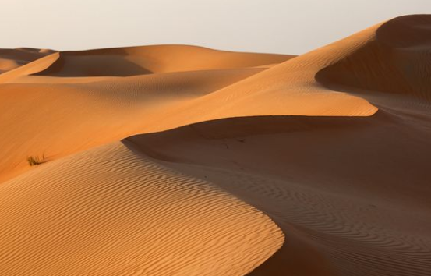
KALAHARI DESERT
The Kalahari Desert is unique among the subtropical deserts. It happens to get significantly more rainfall and support more diverse life than its counterparts. It receives nearly double the rainfall (5-9 inches annually) of the Arabian and Sahara desert, yet portions of the Kalahari still meet the definition of a desert in terms of rainfall.
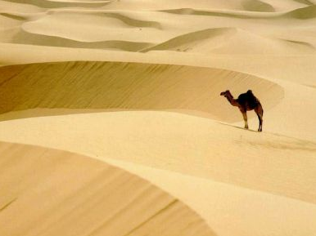 It covers most of the African nations of Namibia, Botswana, and portions of South Africa.
MOJAVE DESERT
The Mojave Desert can be found in the southwestern United States covering parts of southern Nevada and southeastern California. 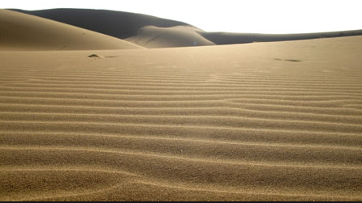 The Mojave Desert contains the scandalous Death Valley, known for being the absolute bottom, driest area, and most smoking territory on the North American mainland. The climate there is described by extraordinary warmth and cool. It can dip under solidifying and surpass 75°F (23°C) in a solitary day. The record high for the Mojave is 134°F (57°C). The record chilly temperature came to was 15°F (- 10°C)!
Bibliography
Arizona-Sonora Desert Museum. 2000. A Natural History of the Sonora Desert
Grass Roots Educators. 2011. The Salton Basin Living Laboratory
Lindsay, Lowell and Diana. 1985. The Anza-Borrego Desert Region.

